MODULE 2 LESSON 3

Imagine that you are reading blog postings from an exchange student who is in Russia.

Полёт был очень долгим, почти десять часов, да ещё разница во времени восемь часов. Во время почти часовой поездки по городу от аэропорта “Шереметьево 2” до Дашиного дома мне очень хотелось спать. Наконец мы приехали!
Дом, в котором живёт Дашина семья, построен пятнадцать лет назад. Это высокий, современный и многоэтажный дом. Мы вошли в подъезд, поднялись на восьмой этаж. Дашина мама, Ирина Владимировна, встретила нас в коридоре. Мы познакомились, она сказала, что обед готов и мы можем сразу садиться за стол. Честно говоря, мне хотелось помыться, принять душ и совсем не хотелось есть. Даша показала мне квартиру и комнату, в которой я буду жить. У Кузнецовых большая четырёхкомнатная квартира.
Большая комната действительно очень большая, здесь обычно собираются все члены семьи. На стене висит большой телевизор, рядом стоит диван и два кресла. В этой комнате стоит большой обеденный стол, но его накрывают только тогда, когда приходят гости. Вся семья завтракает, обедает и ужинает на кухне. Кухня очень большая, здесь тоже есть стол. Комната, в которой я живу, это кабинет Дашиного отца. Это красивая и уютная комната. У стены напротив окна стоит высокий книжный шкаф, рядом большой стол, на котором стоят компьютер и настольная лампа. На столе лежат журналы на русском и английском языках. На стенах висят фотографии самолётов, плакаты международных выставок. На полке над столом можно увидеть семейные фотографии. Рядом со шкафом стоит раскладной диван, на котором я буду спать. В квартире есть большая ванная комната, в которой и туалет, и душ, и большая ванна. В коридоре, недалеко от входной двери, есть ещё один гостевой туалет. Мне очень нравится эта московская квартира. У меня отдельная комната и есть интернет!

Comprehension Checks

Упражнение 1

1. Directions: Match vocabulary words from the text about Dasha’s apartment with the pictures. Write the words on the line below the pictures. No words will be used more than once.
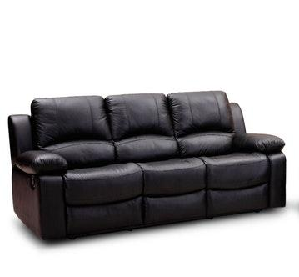
_______________________ ______________________

_________________________ _________________________

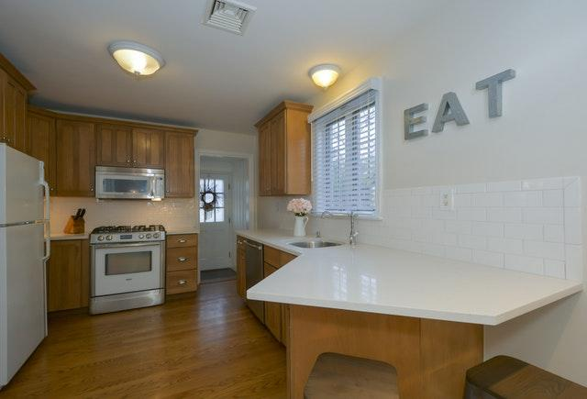
__________________________ _______________________________

______________________ ________________________

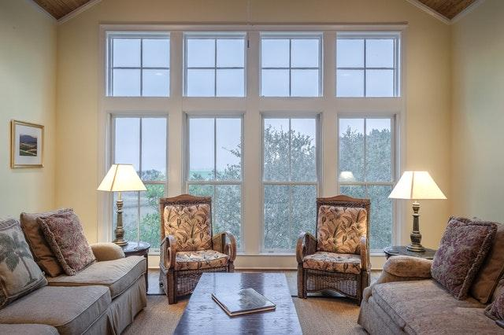
__________________________ _____________________________

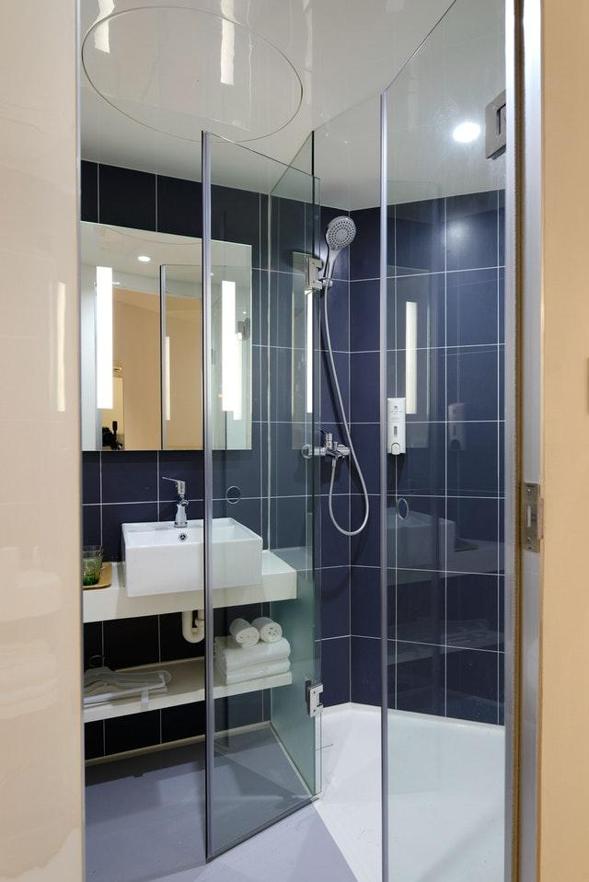
____________________________ ____________________________

2. Directions: Refer to the vocabulary words from the pictures that you labeled to write a draft version of a presentation that you will give to your classmates about Dasha’s apartment. Your draft should include 6-7 sentences and use 12-15 of the vocabulary words from the text about the apartment. You should also include some of the following verbs: помыться, принять, висит/висят, собирается, стоит/стоят, лежит/лежат.

Упражнение 2

Directions: Listen to the message about arriving at the Kuznetsov's home. Pay attention to the exchange student’s reaction to the apartment. Prepare two sentences about what student thinks about the living arrangements. Does he/she like it or not? Why?

Упражнение 3 Household vocabulary

Directions: In each of the categories, write as much appropriate household vocabulary as you can. Work with a partner and add other vocabulary that you know as well as words from the text about the Kuznetsov's apartment.
Дом и квартира | Слова связанные с домом и квартирой
Дом (здание)

Комнаты

Мебель

Как семья проводит время дома

Упражнение 4

Directions: Write a brief blog entry about the student’s arrival and the Kuznetsov's living arrangements.
Include answers to some of the following questions, but write a connected blog entry of 4-5 sentences.

My Blog…

____________________________________________________________________________
____________________________________________________________________________
____________________________________________________________________________
____________________________________________________________________________
____________________________________________________________________________
____________________________________________________________________________
____________________________________________________________________________
____________________________________________________________________________
____________________________________________________________________________
____________________________________________________________________________
____________________________________________________________________________
____________________________________________________________________________

STUDENT PROGRAM LEARNING PLAN
Module 2 Learning Plan #3

Date: |  | Grade Range of Learners: |  | Pre-college students | Targeted Performance Level: | IM
Time Allotted for This Learning Plan: |  |  | 90 min

Lesson Can-Do Statements
Identify specific Lesson Can-Do statement(s) from the Program Can-Do statements in the Curriculum Template (column 2) that are appropriate for and specific to this learning plan.
I can understand simple information about an apartment. (IR)
I can write out a draft of a presentation that I plan to give orally. (PW)
I can understand information about likes and dislikes. (IL)
I can understand postings on blogs on familiar topics. (IR)
I can post an entry to a blog. (PW)

Indicate what learners need to know and understand to meet the Lesson Can-Do statements above.

Culture |  |  | Content |  |  | Language
Russian apartments and living conditions |  | Description of the Kuznetsov’s apartment |  |  | подъезд, многоэтажный, четырехкомнатная  гостевой, раскладной, обеденный

EPISODE # 1 |  | Number of minutes  for this episode: 30
STAGE 1  Lesson Can-Do Statement(s) Addressed: See box above | STAGE 2  Check for Learning  Task or activity learners will do to provide evidence that they are making progress toward the Lesson Can-Do statement(s).
I can understand simple information about an apartment. (IR)  I can write out a draft of a presentation that I plan to give orally. (PW) | Learners complete a graphic organizer based on the text by connecting words to the pictures. Later, they will write 6-7 sentences using the vocabulary words to describe the apartment.
STAGE 3
Enabling Activities
Tasks that lead learners to demonstrate what they can do with what they know.
Learners will match vocabulary words from the text about Dasha’s apartment with the pictures. Learners will write the words on the line below the pictures. No words will be used more than once.
Learners will refer to the vocabulary words from the pictures labeled to write a draft version of a presentation that the learner would give to their classmates about Dasha’s apartment. Your draft should include 6-7 sentences and use 12-15 of the vocabulary words from the text about the apartment.
Differentiation Strategies
Adjustments to instruction or activities to meet learner needs based on age, readiness, process, or output.

EPISODE # 2 |  | Number of minutes  for this episode: 20
STAGE 1  Lesson Can-Do Statement(s) Addressed: See box above | STAGE 2  Check for Learning  Task or activity learners will do to provide evidence that they are making progress toward the Lesson Can-Do statement(s).
I can understand information about likes and dislikes. (IL) | Learners will listen to the blog and will summarize the student’s emotions in two sentences.
STAGE 3
Enabling Activities
Tasks that lead learners to demonstrate what they can do with what they know.
Learners will listen to the message about arriving at the Kuznetsovs’ home. Learners will pay attention to the exchange student’s reaction to the apartment. They will prepare one or two sentences about what student thinks about the living arrangements.
Differentiation Strategies
Adjustments to instruction or activities to meet learner needs based on age, readiness, process, or output.

EPISODE # 3 |  | Number of minutes  for this episode: 20
STAGE 1  Lesson Can-Do Statement(s) Addressed: See box above | STAGE 2  Check for Learning  Task or activity learners will do to provide evidence that they are making progress toward the Lesson Can-Do statement(s).
I can understand postings on blogs on familiar topics. (IR) | Learners will read the blog and complete graphic organizer on household vocabulary.
STAGE 3
Enabling Activities
Tasks that lead learners to demonstrate what they can do with what they know.
In each of the categories, learners will write as much appropriate household vocabulary as you can. They will work with a partner and add other vocabulary that they know as well as words from the text about the Kuznetsovs’ apartment.
Differentiation Strategies
Adjustments to instruction or activities to meet learner needs based on age, readiness, process, or output.

EPISODE # 4 |  | Number of minutes  for this episode: 20
STAGE 1  Lesson Can-Do Statement(s) Addressed: See box above | STAGE 2  Check for Learning  Task or activity learners will do to provide evidence that they are making progress toward the Lesson Can-Do statement(s).
I can post an entry to a blog. (PW) | Write a brief blog entry about the student’s arrival to the Kuznetsovs’ living arrangements in 4-5 sentences.
STAGE 3
Enabling Activities
Tasks that lead learners to demonstrate what they can do with what they know.
Include answers to some of the questions suggested in the task, but write a connected blog entry of 4-5 sentences.
Differentiation Strategies
Adjustments to instruction or activities to meet learner needs based on age, readiness, process, or output.

Add additional learning episodes as needed by copying a learning episode box.

MATERIALS NEEDED
What supplies and materials will you need to successfully implement this learning plan?

PERSONAL REFLECTION
How did this lesson go? What could you do to improve this learning plan if you do these activities again?

