**STUDENT PROGRAM LEARNING PLAN**

**Title: Let’s Meet Some Animals from The Target Country**

Note: The model Learning Plan below is an exemplar. It includes various tasks in the three modes of communication as a reference for STARTALK Program Directors, Lead Instructors, and teachers as they plan lessons and learning episodes. These plans are not meant to be followed exactly because every program is different. Instead, they are meant to give ideas on how learning plans might be implemented. **These plans include more detail than is required.** STARTALK encourages comprehensive plans but does not require the level of detail included here.

*For step-by-step help in completing this document, please see the accompanying* [*annotated learning plan*](https://startalk.umd.edu/public/system/files/resources/studentprogramannotatedlearningplan.pdf) *and sample learning plans.*

|  |  |  |  |  |  |
| --- | --- | --- | --- | --- | --- |
| **Date:** |  | **Grade Range of Learners:** | **K-2** | **Targeted Performance Level:** | **NM** |
| **Time Allotted for This Learning Plan: 90 Minutes** | | | | | |

|  |
| --- |
| **Lesson Can-Do Statements**  *Identify specific Lesson Can-Do statement(s) from the Program Can-Do statements in the Curriculum Template (column 2) that are appropriate for and specific to this learning plan.* |
| Interpersonal Speaking   * I can say my name. * I can say where I live. * I can name 3 to 5 animals. (Choose animals with different sizes, different ways of moving, different colors and different things they eat.) * I can describe the animals’ colors, size, where they live, how they move, and what they eat. ) * I can ask and answer simple questions about animals.   Interpretive Listening   * I can recognize the names of a few animals. * I can recognize some facts that I have learned about animals.   Presentational Speaking   * I can name a few animals. * I can tell some facts about the animals |

*Indicate what learners need to know and understand to meet the Lesson Can-Do statements above.*

|  |  |  |  |  |  |
| --- | --- | --- | --- | --- | --- |
| **Culture** |  | | **Content** |  | **Language** |
| Animals connected to the culture | | How animals are used in the culture | | Names of a few animals  My name is ___.  The ( animal) lives in (Target country).  The animal is red/white/brown/black….  The ____ eats…  The ____ lives in…  The ____ is big, small.  The ____ has (2/4/no) legs.  The ____ moves on the land, in the water, in the air.  The ____ is (color).  The ___ swims, flies, walks. | |
|  | |  | | **Note: Additional practice with this vocabulary will continue in later learning plans.** | |

|  |  |
| --- | --- |
| **EPISODE # 1 Number of minutes****for this episode:** 30 | |
| **STAGE 1**  **Lesson Can-Do Statement(s) Addressed:** *See box above* | **STAGE 2**  **Check for Learning**  *Task or activity learners will do to provide evidence that they are making progress toward the Lesson Can-Do statement(s).* |
| I can name 3 to 5 animals. | Using the animals’ name tags students walk around the room, find at least 4 different partners and ask and answer the questions “*What is your name?” “ My name is ____.” “Where do you live?” “ I live in _____.“* |

**STAGE 3 Enabling Activities**

*Tasks that lead learners to demonstrate what they can do with what they know.*

1. The teacher enters the classroom with stuffed animals or large, colorful visuals representing 3 to 5 animals and introduces them to the class. He/She then uses the stuffed animals to ask students their names and where they live, in the target country or in the US. *I Do*

*Hello, my name is Panda. What is your name? Is it Panda? Is it___?*

*I live in China. Do you live in China too? Do you live in the US?*  As the teacher asks the question about where the students live, he/she shows or points to a world map that shows both countries.

1. The teacher distributes name tags to students. As the teacher distributes the name tags, he/she engages students in responding to the questions, “*What is your name?*” and *“Where do you live?”*

Students participate in a line-up activity. Students on each side of the line ask and answer the questions “*What is your name?” “ My name is ____.” “Where do you live?” “ I live in _____.“* They will ask and answer the questions with every student in the line. The teacher provides sentence and question frames (either on the board or on sheets for each individual student) for students to use when telling their names and where they live. *We Do Guided*

1. The teacher distributes another name tag, this time with the name or picture of an animal from the target country. As the teacher distributes the animal name tags, he/she again models the same question and answer with some students. “*What is your name?* “*“Where do you live?”* and helps students to respond to the questions. This time the students respond with: “*My name is ( Name of animal).” “ I live in _______.”* The teacher provides sentence and question frames for students to use when telling the names of their animal and where they live. *We Do Guided*
2. The teacher helps students practice the new vocabulary by asking those with the name tags of certain animals and the animals who live in a certain country to hold up their names tags, wave their hands, to jump up and down or to give some other sign.  *You Do*
3. Using the animals’ name tags students walk around the room, find at least 4 different partners and ask and answer the questions “*What is your name?” “ My name is ____.” “Where do you live?” “ I live in _____.“ You Do*
4. Students post their name tags and the name tags for the animals on the class word wall. *You Do*

|  |
| --- |
| **Differentiation Strategies**  *Adjustments to instruction or activities to meet learner needs based on age, readiness, process, or output.* |
| Some students will be able to complete the activities without the sentence and question frames. |

|  |  |
| --- | --- |
| **EPISODE # 2 Number of minutes****for this episode:** 30 | |
| **STAGE 1**  **Lesson Can-Do Statement(s) Addressed:**  *See box above* | **STAGE 2**  **Check for Learning**  *Task or activity learners will do to provide evidence that they are making progress toward the Lesson Can-Do statement(s).* |
| * I can recognize the names of a few animals. * I can recognize some facts that I have learned about animals. * I can tell the color of an animal | Students find a partner, and tell the partner which animal visual they have and one fact about each animal. |

**STAGE 3 Enabling Activities**

*Tasks that lead learners to demonstrate what they can do with what they know.*

1. The teacher projects or shows large visuals of 3-5 pictures depicting animals from the target culture. The teacher talks about the animals, naming and describing each one using words, chunks of language, gestures, body language, and props. He/She talks about these animals more than once ensuring that students understand the key facts: name of the animal, its colors, size, where it lives, and how it moves. *I Do*

For example:

*The Panda is black, white and big. He eats leaves and lives on the land. He walks.*

*The Polar Bear is white and very big. He eats fish and he lives on the land and in the water. He walks and swims.*

*The dolphin is grey. He eats other fish and plants, he lives in the water and swims.*

*The parrot is blue, green, red and yellow. He eats seeds and he lives on the land (in trees). He flies.*

*(Programs will choose animals related to the target country. The animals above were chosen to demonstrate how the activity works. )*

1. The teacher asks yes/no, either/or questions about the animals and their characteristics and uses thumbs up/thumbs down technique to check for understanding. *We Do Guided*
2. The teacher and students work collaboratively to create a Comparison/Contrast chart as a concept organizer for the target culture animals. Students use the chart to guide them in class activities. *We Do Guided*

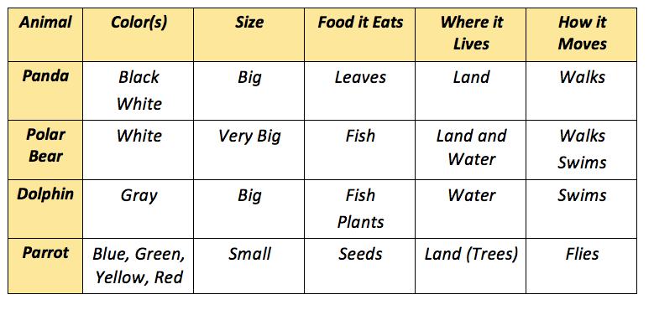

1. The teacher distributes a large, colorful visual of the new vocabulary to each student. On the teacher’s signal, students mingle. When the teacher signals them, they stop, find a partner, and tell the partner which animal they have. (“*I have ___.*”) They choose a fact from the chart tell their partner one fact about each animal. (“The ____ is big.” Or “The ___ walks.” “The ___ and the ____ walk. ““The ___ walks but does not fly.”) This can be repeated with several partners. *You Do*

*(Note: In later episodes –not included in this learning plan--the activity can be brought back again but this time the students must give 2, 3 and 4 facts about the animals.)*

|  |
| --- |
| **Differentiation Strategies**  *Adjustments to instruction or activities to meet learner needs based on age, readiness, process, or output.* |
| The teacher provides sentence frames to aid communication.  The teacher creates the comparison/contrast chart with pictures. |

**EPISODE # 3 Number of minutes****for this episode:** 30

|  |  |
| --- | --- |
| **STAGE 1**  **Lesson Can-Do Statement(s) Addressed:** | **STAGE 2**  **Check for Learning**  *Task or activity learners will do to provide evidence that they are making progress toward the Lesson Can-Do statement(s).* |
| * I can name 3-5 animals. * I can tell some facts about the animals | Once the students have completed the diagram each partner explains it orally to the other partner by creating their own sentences based on the diagram. |

**STAGE 3 Enabling Activities**

*Tasks that lead learners to demonstrate what they can do with what they know.*

1. The teacher displays visuals and concrete referents that represent the new vocabulary presented and practiced in episodes 1 and 2. The teacher may display the items on the board, the floor, or put them in a large box or basket. The teacher then asks students to, *“Bring me…, please.” We Do*
2. Next, the teacher shows a picture of one of the animals being studied. With help from the teacher and the chart from the previous episode, the students answer the questions. *We Do Guided*

* What color is this animal?
* Is it big or small?
* What does this animal eat?
* Where does this animal live? In the target country or in the US?
* How does this animal move?
* How many legs does this animal have?

As the students are answering the questions, the teacher creates a Venn Diagram on the board with pictures, words, or a combination of words and pictures. The Venn Diagram shows the way that the animals are similar to and different from each other. Below is an example of a diagram that the teacher might create based on how the animals move.

**Venn Diagram; How Do the Animals Move?**

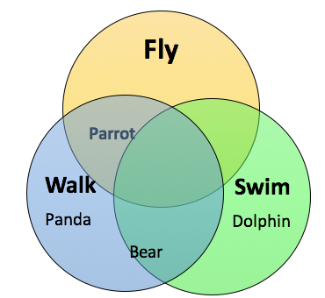

After the Venn Diagram has been completed. The teacher leads the students in making sentences based on the diagram. *We Do Guided*

The parrot flies and walks.

The dolphin swims.

The polar bear walks and swims.

The panda walks.

1. Once the teacher and students together have completed the *How Do the Animals Move* Venn Diagram, the teacher gives each pair of students a plastic bag with small pictures of the vocabulary and an individual Venn diagram on which they can place the pictures. With the teacher’s help, students find pictures to recreate the Venn Diagram that has just been completed on the board. *We Do Guided*

Once the students have completed the diagram each partner explains it orally to the other partner by creating their own sentences based on the diagram. These are the same sentences that the teacher created with the whole class. You Do

The parrot flies and walks.

The dolphin swims.

The polar bear walks and swims.

The panda walks.

1. Students work independently with their partner to create additional Venn Diagrams on the size of the animals (big, very big, small), where the animals move (land, air, water), or how many legs the animals have.
2. The teacher asks several pairs to present their new Venn Diagrams to the rest of the class. The teacher leads the class in making sentences explaining the two new diagrams. We Do Guided
3. Then the teacher asks the students to explain their diagrams to the other partner without the help of the teacher. If there is time, the partners can explain their diagrams to another set of partners. *You Do*

|  |
| --- |
| **Differentiation Strategies**  *Adjustments to instruction or activities to meet learner needs based on age, readiness, process, or output.* |
| The teacher scaffolds his/her questions using the natural order of questioning (yes/no, either/or, what is?)  The Venn Diagrams can be completed with pictures only, with words only, or with a combination of words and pictures. |

|  |
| --- |
| **MATERIALS NEEDED**  *What supplies and materials will you need to successfully implement this learning plan?* |
| Large, colorful visuals of animals and possibly, puppets or stuffed animals  Small visuals of animals, colors, foods eaten, and animal movements  Venn Diagram graphic organizer sheets |

|  |
| --- |
| **PERSONAL REFLECTION**  *How did this lesson go? What could you do to improve this learning plan if you do these activities again?* |
|  |

**Another strategy for helping students remember vocabulary and information is a Word Map using the Frayer Model**

Teachers and students collaborate to create Frayer Model word map for each animal. (See <http://www.theteachertoolkit.com/index.php/tool/frayer-model)> They construct the word maps with pictures and/or text. They post the word maps on the classroom wall as a reference tool for students. *We Do Guided*

***Word Map***

